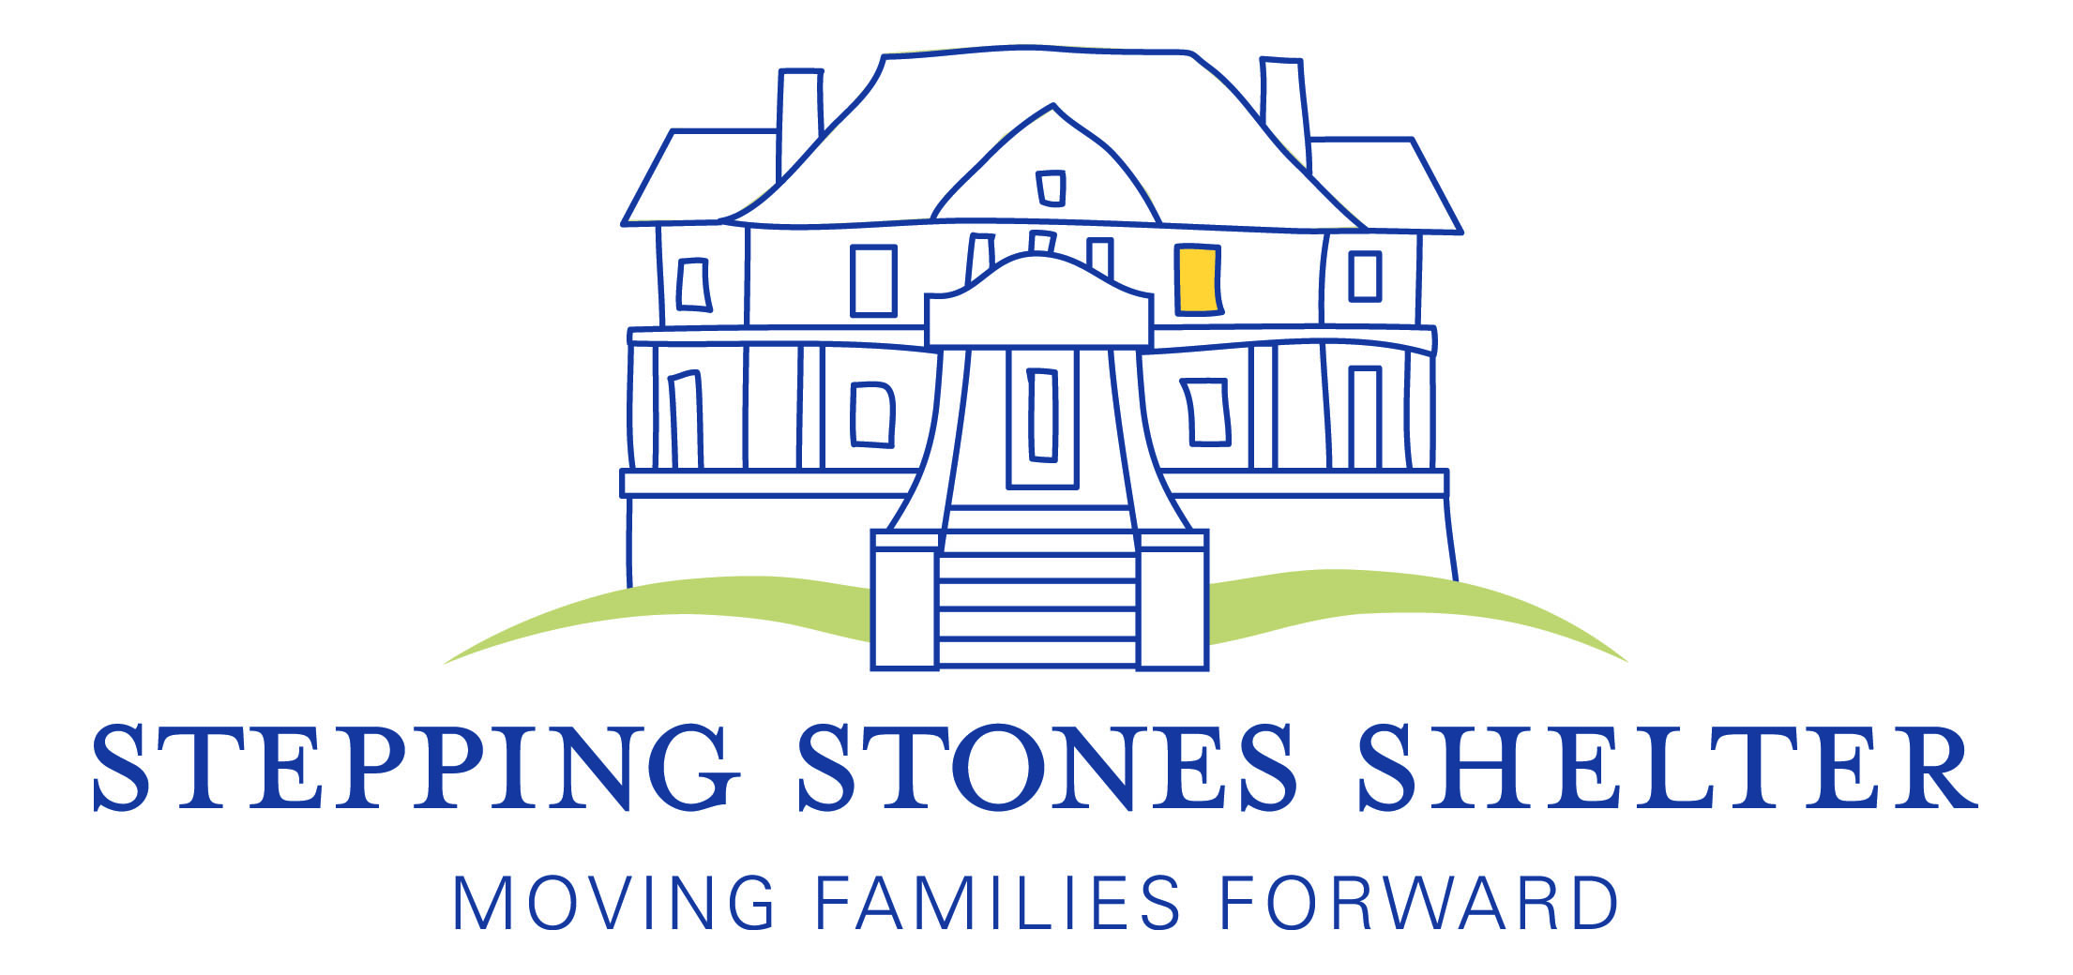
Stepping Stones Shelter Fiscal Year 2014 Annual Report
Mission Statement
Stepping Stones Shelter Inc. provides a continuum of services (emergency shelter, permanent supportive housing, and post-shelter support) to homeless families with children in order to move them from crisis to a stable home environment. By offering food, shelter and supportive services in an atmosphere of dignity and respect, Stepping Stones provides hope for the future, strengthens families, and promotes self-sufficiency.

Programs/Services

Stepping Stones has been serving the community for 32 years. Our Emergency/Assessment Shelter achieves our mission by providing food, shelter and:
- Case management services to connect homeless families to needed services in the community, and to help families develop income and housing solutions;
- Employment counselors who work one-on-one to provide intense employment and career counseling;
- Tutoring for the children and GED tutoring, if needed, for the adults;
- Post-shelter support for families that have moved on from the shelter but still need help with referrals and in-kind donations in order to remain housed.
In addition to our emergency shelter, through an 12 year partnership with the Montgomery County Coalition for the Homeless, Stepping Stones Shelter provides permanent supportive housing to two large families with disabled heads of household. The Hope Housing Program allows each family to remain together and housed, living in their own townhouses with wrap-around services including financial supports for housing and basic needs, education/training supports, and ongoing case management.

Impact

“I got a job today and I am so happy and grateful for Stepping Stones’ support.”—Jenny, former shelter resident

In FY 2014, Stepping Stones Shelter served 22 families (71 individuals) in the emergency shelter; 2 families (10 individuals) in Hope Housing; and 50 former resident families. Due to the services and supports our emergency shelter families received:
- 94% moved on to more stable housing.
- 100% of families had income by the end of their shelter stay.
- 93% of shelter families were able to gain or maintain a work activity during their stay.
- 77% of the families were able to reduce their debt or began to address their debt issues during their shelter stay.
- Of the families who stayed at least 14 days, 100% created a budget, 93% received a copy of their credit reports and 100% were connected to supportive services.
- 100% of the shelter children attended school on a regular basis and 100% of the school-aged children were attending tutoring in the shelter.
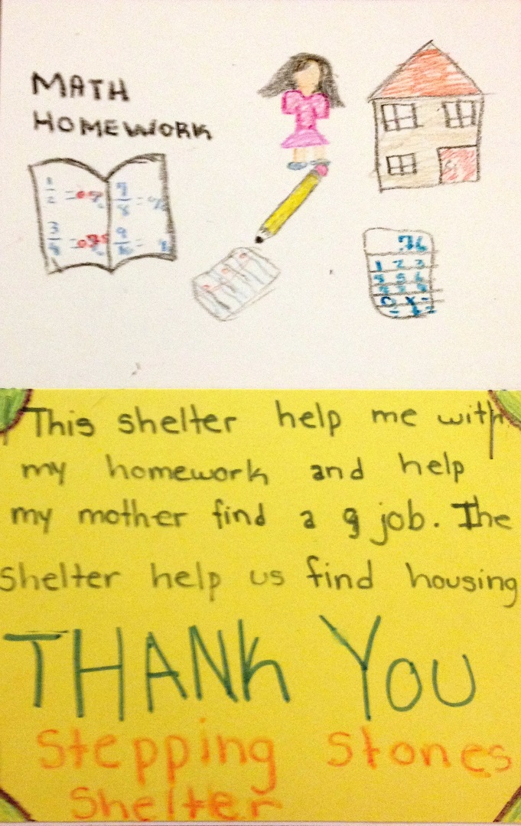

Who We Serve
Our clients were all Montgomery County residents before becoming homeless. While we serve any configuration of family with children, the majority of the families we serve are headed by single mothers; in FY 2014, 77% of the families had a female head of household, 23% were young mothers aged 18-25. Two-parent families accounted for 23% of those we served in our emergency shelter. Almost all of our residents have a number of barriers to housing which makes finding housing on their own very difficult. These barriers include low income, large families, bad credit, undocumented immigration status, criminal backgrounds, and a history of evictions. Some of our residents grew up in public housing or in shelters; some have never had stable housing or are leaving home for the first time. Some of our residents have a history of mental illness, domestic violence or substance abuse. There are also clients who simply do not make enough money to cover daily living expenses such as rent, food, childcare and medical expenses. According to the Self-Sufficiency Standard for Maryland 2012 (Maryland Community Action Partnership), in Montgomery County a family of three consisting of one adult, one pre-school child and one school age child would need to have an income of $77,933/year to be able to live in Montgomery County without financial assistance. (The families we see at the shelter usually have an income of less than $20,000/year and some have no income at all.)

Kasey, Michelle (12), and David (5) became homeless when Kasey had to stop working due to chronic medical issues and was unable to afford rent. During their 4 month stay at Stepping Stones, the family celebrated Christmas and David's 5th birthday in the shelter. This family was accepted into a permanent housing program and moved into their very own townhouse. They look forward to spending holidays and birthdays in their new space and are so grateful to supporters like you. As she was leaving, Kasey turned and said “I don’t know what would have happened to my family if we hadn’t come to Stepping Stones. I will always be thankful.”

Fiscal Year 2014 Audited Financials

Revenue
Government Contracts/Grants | $415,429 | 59.86%
Private Gifts | $133,891 | 19.3%
Events | $ 66,354 | 9.56%
Foundations | $ 56,515 | 8.14%
Investments | $ 4,219 | .6%
Other Income | $ 17,656 | 2.54%
Total | $694,064 | 100%

Expenses
Programs | $549,671 | 81.23%
Administration | $ 50,476 | 7.46%
Fundraising | $ 76,570 | 11.31%
Total | $676,717 | 100%

FY 2014 Board of Directors

Peter Deoudes, President Kate Dawson Andy Navarette
Ellen Kearon, Vice President Michelle Logsdon Jonathan Neal
William Buskirk, Treasurer Marilyn Massey-Ball Michael Rose
Murvell Delpino, Secretary Raul Medrano

From the Executive Director
Thank you! Everything we have accomplished in Fiscal Year 2014 is due to our wonderful supporters. Without your monetary donations, in-kind donations such as meals, diapers, cleaning supplies and paper goods, and all the volunteer time you have so generously given to us, we would not be able to fulfill our mission to help homeless families move forward toward safe and stable housing. From corporate community engagement groups to Girl Scout troops to religious organizations and students in our local schools, our community has come together in so many ways to help the families we serve. Thank you so much for continuing to help change so many lives for the better.

Denise Fredericks
Executive Director

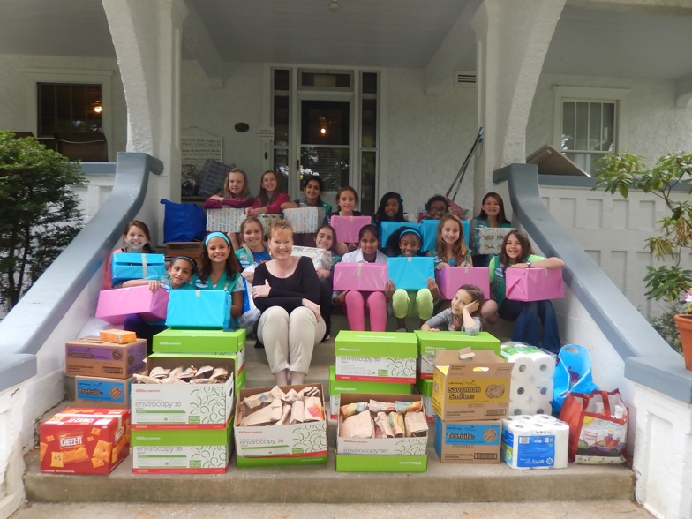

FY 2014 Donors and Supporters
This list includes the generous giving/support Stepping Stones received between July 1, 2013 and June 30, 2014. We regret any error or omission, and ask that corrections be brought to our attention. Please contact Denise Fredericks at 301-251-0567 or denise@steppingstonesshelter.org. Thank you.

Congregations
Alive in the Spirit Ministries
Bethesda Jewish Congregation
B’nai Israel
Boyds Presbyterian Church
Cedar Ridge Church
Charis Worship Center
Church of the Latter Day Saints
Connection Church
Darnestown Presbyterian Church
Fairhaven United Methodist Women
Jewish Federation of Greater Washington
Montgomery Baptist Church
OR Haolam Ministries, Inc.
Potomac Presbyterian Church
Potomac United Methodist Church
Rockville Presbyterian Church
St. Elizabeth Catholic Church
St. Mark’s Orthodox Church
St. Mary Catholic Church
St. Patrick Catholic Church
St. Raphael Catholic Church
Temple Beth Ami
Ten Women Prayer Group
The People’s Community Baptist Church
Tikvat Israel Tzedakah Fund
Trinity Evangelical Lutheran Church
United Methodist Church
Women of St. Francis

Community/Civic Organizations
American Legion Auxiliary
Bright Horizons
Charities Angels
Conflict Resolution Center of Montgomery County
Gaithersburg Corvette Club
Girl Scout Troop 1592
Girl Scout Troop 3385
Girl Scout Troop 4987
Hip Replacements Band
Jewish Social Services
Knights of Columbus
Ladies Auxiliary of Elks Lodge #15
Layhill Village Women’s Club
Leisure World Kiwanas Club
Manna Food Center
Moms Club of Great Seneca
Montgomery County 4-H Beef Club
Montgomery County 4-H Sheep and Swine Club
Nourish Now
Progress Club
Project Sunshine
Stay Safe Coalition
United Way of the National Capital Region
Woman’s Club of Chevy Chase

Schools
Bells Mill Elementary School
Bullis School
Charles E. Smith Jewish Day School
Georgetown University
Holton Arms School
Julius West Middle School
Kids After Hours
Luxmanor Elementary School
Meadow Hall Elementary School
Reid Temple Christian Academy
Richard Montgomery High School Honors Society and SGA
Ronald McNair Elementary School
Seneca Academy
Stonegate Elementary School
The Ark (preschool of Oakdale Emory Methodist Church)
University of Maryland Scholar Group
Washington Christian Academy
Watkins Mill High School
Corporations/Businesses
3M
Allied Insurance Services
Allied Party Rentals
AERAS
As Kindred Spirits
Aspen Hill Club
Avendra
Baker Family Limited Partnership
Bark!
Baywood Hotels
Biro Dominican Salon
Booz Allen Hamilton
Broadstreet LLC
Cabot Creamery Cooperative
Caldwell and Company
Capital Bank
Capital One Bank
CareerCatchers
Carnival Day
Carlyn and Company Interiors and Design
Choice Hotels/Rebuilding Together
Clover Restaurant Group
Clyde’s Tower Oaks
Cohen Reznick
Curves of Olney
Dawson’s Market
Del Frisco’s Restaurant Group
Double D Financial Services
Drink More Water
Dyer & Associates, P.C.
Embrace Home Loans
Endless Coffee
Excel HR
Exxon Mobil Corporation
Fannie Mae
Fitzgerald Auto Mall-Gaithersburg
Fraiche Cupcakery
FSM Leasing Inc.
Fortigent LLC
Fujimar Restaurant
Geppetto Catering Inc.
Giant Food
Hanna’s Connection
Hornberg Insurance Services
Howard Insurance
iKona Photography
Il Porto Fine Italian Restaurant
Jodi’s Jamboree
Law Offices of Maxwell and Barke, LLC
Ledo Pizza
Lima Lounge
Lockheed Martin
Maier & Warner Public Relations, LLC
Marsha Douma, DDS
Maryland Gardens
Merle Norman
Metropolitan Moving and Storage
MIDAKIP
Mon Ami Gabi—Bethesda
Monique’s Esthetique
Morgan Stanley
MRIS
NRG Energy
Next Level Studio
Not Your Average Joe’s
Old Line Fine Wine Spirits and Bistro
Pepco
PetValu
Pigtails and Crewcuts
Potomac Pilates
Potomac Village Deli
Print 1
Red Door Spa, Elizabeth Arden
Rocklands BBQ—Rockville
Rocklands Farm
Roots Market
SAS Inc.
S & K Roofing, Siding and Windows, Inc.
Salon Central
Seneca Land, LLC
Society Lounge
Southwest Airlines
Sport & Health Club
Sports World
Starbucks
Suntrust Mortgage
Talk of the Town
Target
The H.T. Than Law Group
The Shop Salon--Bethesda
The Treatment and Learning Centers
Total Wine and More
Truist
Qiagen, Inc.
Quench
United Capital Private Wealth Counseling
Urban Butcher
Verizon Telecom Pioneers
Vesta, Inc.
Vis Arts
WPG Solutions, Inc.
Waiter on the Way
Zengo Cycle
Zoe’s Kitchen

Foundations/Trusts
Alice Shaver Foundation
Alice Von Saunder Trust
American Charities
Benevity Community Impact Fund
Carl M. Freeman Foundation
Clark Winchcole Foundation
Community Foundation of the National Capital Region
Community Foundation for Montgomery County
Cortright Family Charitable Foundation
Faith United Methodist Foundation
ImmixGroup Foundation
Kiwanis Foundation of Rockville, MD
Laszlo Tauber Family Foundation
Lt. Thomas Joseph Hill Memorial Foundation
Montgomery Alliance
Pettit Family Charitable Foundation
Safeway Foundation
The Pew Charitable Trust
The V. and S. Foundation
United Jewish Foundation
Venable Foundation
Webber Family Foundation
Wilmington Trust
WMY Fund

Government
City of Rockville
City of Gaithersburg
Emergency Food and Shelter Program (FEMA)
Infants and Toddlers Program (DHHS/MCPS)
Montgomery County Council
Montgomery County Department of Health and Human Services
National Institutes of Health
United States Dept. of Housing and Urban Development

Individuals
$5,000+
J. Roberto Gracia
Jonathan and Katherine Tomares

$2,500-$4,999
Scott and Patrice Brickman
Mark Freedman
Marvin H. McIntyre
Glen and Barbara Rempe
Cliff and Deborah White

$1,000-$2,499
Jeffrey Butvinik
Brad and Adrienne Cohen
Pete Deoudes
Charles Gravely
Robert and Amy Hamilton
Charles and Emily Kim
Marilyn Massey-Ball
Jack D. Neal and Family
Michael and Tricia Rose
David and Carolyn Stump
Jeffrey and Irene Tebbs

$500-$999
Deborah G. Astrove
Blake and Nancy Averill
Stanley and Shelley Balis
Bill and Shannon Buskirk
Michael and Denise Cetta
Joyce Cormier
Julie-Anne Cronin
M. Quinn Dawson
Gary Edmonds
Lisa and Mitchell Eisen
Carrie and Avi Halpert
Bob and Amy Hamilton
Jonathan and Roberta Jacobson
Ellen and Robin Kearon
Karen Miler
Steven Powers
Allan and Julie Rutter
Shelly and Hal Stuart
Carolyn Young

$100-$499
Patricia Abate
John and Nancy Abeles
Brigitte and Mehrdad Abrishami
Joseph Adler
JoAnne and Eric Aellen
John and Sarah Anderson
Wendy and Joshua Band
Patricia Brennan
Lois and Mimi Brodsky
Paul and Katherine Brown
Jason and Amy Buckner
Michele and David Cade
Lynn R. Charytan
Jean A. Clark
Kevin and Frances Cleary
Lori Clogg
David and Susan Cohen
Patricia and Alan Cohen
Carolyn Cullen
Kate Dawson
Barbara Degler
Christine Dingivan
Charles E. Diss Jr.
Debra Donovan
Andrew Drennon
Christopher and Beth Dromerick
Dorothy and J. Bennett Easterling
Ruth Edelman
Richard and Inez Ernst
M. Ferzacca
Krista Fiabane
Gerald Flood
Donna Foster
Christine Curry Freeland
Laura Frene
Janet and Robert George
Laurel Glassman
Yolanda M. Goettsch
Gina and Robert Goodfellow
Renata Greenspan
Kenneth and Judith Halperin
Minister Love Huyah
Winifred Hyson
Jonathan Eig and Karen Jerome
Myles and Ruth Johnson
Jan King
Aileen Klein
Audrey Koch
Susan Luger
Theodore Lutterman
Robert and Eileen MacFarlane
Ruth Marcus
Donald and Mary Lou Marlowe
Marshall and Ursula Martin
Daniel and Amy Matathias
Anu Mathew
H. Clay Miller III
Belinda and Gregory Nixon
Beverly and Robert Piccone
Jay and Susan Plafker
Mari Plagge and Charles Rabkin
Terri Reicher
Mr. and Mrs. Claude Rollin
Kirsten and Johnathan Romm
Rebecca M. Tabakin
Jay Goodman and Rebecca Salon
Michael Copperman and Maria Schiff
David and Stacy Schlactus
Mr. and Mrs. Laurance Schor
Donald and Isabelle Schuessler
Kristina Sherman
Tom and Marilyn Sherman
Eric and Sue-Ann Siegel
Toni Skladany
Susan Swift
William Synder
Casey Thompson
Rachel Thompson
Thomas and Elizabeth Trabucco
James Weitzman
Kyle Yost
Walter and Deborah Ziffer
David and Teresa Zolet

Stepping Stones Shelter P.O. Box 712, Rockville, MD 20848 301-251-0567
www.steppingstonesshelter.org

