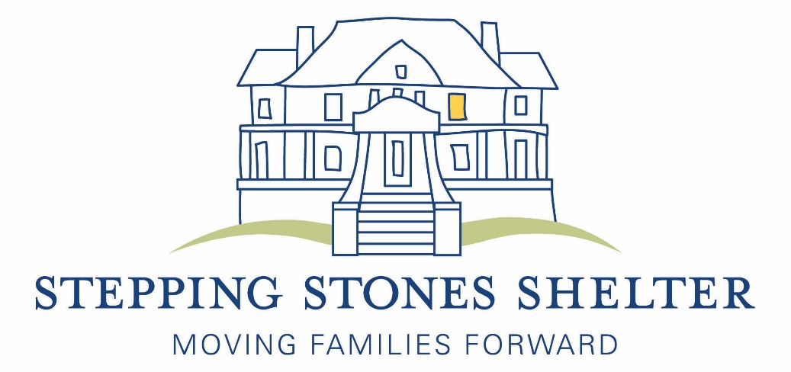
Stepping Stones Shelter Fiscal Year 2015 Annual Report
Mission Statement
Stepping Stones Shelter Inc. provides a continuum of services (emergency shelter, permanent supportive housing, and post-shelter support) to homeless families with children in order to move them from crisis to a stable home environment. By offering food, shelter and supportive services in an atmosphere of dignity and respect, Stepping Stones provides hope for the future, strengthens families, and promotes self-sufficiency.

Programs/Services

Stepping Stones has been serving the community for 33 years. Our Emergency/Assessment Shelter achieves our mission by providing food, shelter and:
- Case management services to connect homeless families to needed services in the community, and to help families develop income and housing solutions;
- Employment counselors who work one-on-one to provide intense employment and career counseling;
- Tutoring for the children and GED tutoring, if needed, for the adults;
- Post-shelter support for families that have moved on from the shelter but still need help with referrals and in-kind donations in order to remain housed.
In addition to our emergency shelter, through a 13 year partnership with the Montgomery County Coalition for the Homeless, Stepping Stones Shelter provides permanent supportive housing to two large families with disabled heads of household. The Hope Housing Program allows each family to remain together and housed, living in their own townhouses with wrap-around services including financial supports for housing and basic needs, education/training supports, and ongoing case management. In 2014 we started providing service coordination services to 6 families in the Housing Initiative Program (HIP), a permanent supportive housing program run by the Montgomery County Department of Health and Human Services.

Impact

“I have learned so much since being here and I have also received a lot of help from staff, case workers and volunteers. Thank you so much.” –former resident Yvonne

In FY 2015, Stepping Stones Shelter served 34 families (121 individuals) in the emergency shelter; 2 families (10 individuals) in Hope Housing; 6 families in the Housing Initiative Program (HIP); and 65 former resident families. Due to the services and supports our emergency shelter families received:
- 92.6% moved on to more stable housing.
- 93.6% of families had income by the end of their shelter stay.
- 55.5% of shelter families were able to gain or maintain employment during their stay.
- 90% of the families that had debt were able to reduce their debt or began to address their debt issues during their shelter stay.
- Of the families who stayed at least 14 days, 100% created a budget, 96% received a copy of their credit reports and 100% were connected to supportive services.
- 100% of the shelter children attended school on a regular basis and 100% of the school-aged children were attending tutoring in the shelter.
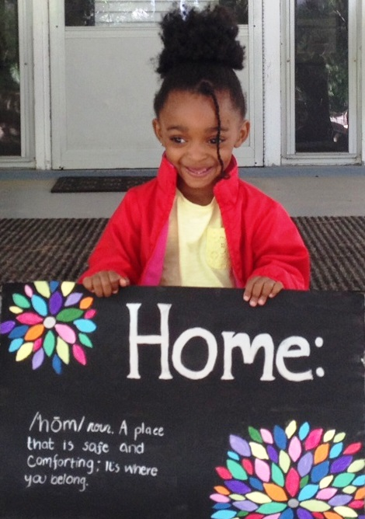
Who We Serve
Our clients were all Montgomery County residents before becoming homeless. While we serve any configuration of family with children, the majority of the families we serve are headed by single mothers; in FY 2015, 76% of the families had a female head of household, 38% were young mothers aged 18-25. Two-parent families accounted for 24% of those we served in our emergency shelter. Almost all of our residents have a number of barriers to housing which makes finding housing on their own very difficult. These barriers include low income, large families, bad credit, undocumented immigration status, criminal backgrounds, and a history of evictions. Some of our residents grew up in public housing or in shelters; some have never had stable housing or are leaving home for the first time. Some of our residents have a history of mental illness, domestic violence or substance abuse. There are also clients who simply do not make enough money to cover daily living expenses such as rent, food, childcare and medical expenses. According to the Self-Sufficiency Standard for Maryland 2012 (Maryland Community Action Partnership), in Montgomery County a family of three consisting of one adult, one pre-school child and one school age child would need to have an income of $77,933/year to be able to live in Montgomery County without financial assistance. (The families we see at the shelter usually have an income of less than $20,000/year and some have no income at all.)

Breanna, a 24 year old mother of three daughters, ages 7, 4 and 1, was homeless again. A victim of domestic violence, she had spent some time in the county’s domestic violence shelter and received a rental subsidy for an apartment in the community. Months later, unable to pay the rent regularly with her waitressing job, she became homeless again and came to Stepping Stones Shelter. At the shelter she established a savings account, received and reviewed her credit report and created a budget so she can closely monitor her finances. She worked with a therapist to keep her anxiety in check, and throughout it all she managed to keep her waitressing job. While at the shelter she was able to participate in the 8 week parenting class where she exclaimed that the class was amazing—she was excited to learn how to interact appropriately with her daughters at their different ages and development levels. She worked with the shelter case managers on a housing solution, and after spending 88 days at Stepping Stones, Breanna was able to move into a Young Moms transitional housing program that will allow her two years to get training to increase her income so she can find housing that she can afford.

Fiscal Year 2015 Audited Financials

Revenue
Government Contracts/Grants | $458,858 | 59.4%
Private Gifts | $141,355 | 18.3%
Events | $ 43,356 | 5.6 %
Foundations | $109,652 | 14.2%
Investments | $ 3,488 | .4 %
Other Income | $ 16,376 | 2.1%
Total | $773,085 | 100%

Expenses
Programs | $571,162 | 79.68%
Administration | $ 76,155 | 10.62%
Fundraising | $ 69,517 | 9.70%
Total | $716,834 | 100%

FY 2015 Board of Directors

Ellen Kearon, President Murvell Delpino
Marilyn Massey-Ball, Vice President Natalie Dodson
William Buskirk, Treasurer Helen Domenici
Michelle Logsdon, Secretary Lynn Johns
Raul Medrano
Andy Navarrette
Jonathan Neal
Shelley Rothenberg
William Rothwell

We are grateful for the support of all of the individuals, companies, and organizations who make our work possible. On behalf of the Board of Directors, the staff, and the many families we serve, THANK YOU.

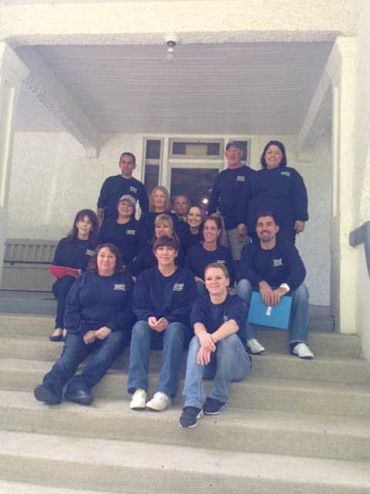

FY 2015 Donors and Supporters
Included below are the amazing groups in the community that have supported us with in-kind and/or monetary donations. The individuals listed are for monetary donations only. We greatly appreciate all the in-kind donations and volunteer time that so many individuals contributed this year but the names are too numerous to list. This list includes the generous giving/support Stepping Stones received between July 1, 2014 and June 30, 2015. We regret any error or omission, and ask that corrections be brought to our attention. Please contact Mary Bennett at 301-251-0567 or mary@steppingstonesshelter.org. Thank you.

Congregations
Bethesda Jewish Congregation
B’nai Israel
Boyds Presbyterian Church
Calvary Lutheran Church
Christ Episcopal Church
Church of the Latter Day Saints
Church of the Redeemer
Connection Church
Darnestown Presbyterian Church
Derwood Alliance Church
Emmanuel Lutheran Church
Fairhaven United Methodist Women
Hadassah
Jerusalem Baptist Church
Jerusalem Charismatic Community Church
Kehilat Shalom
Local Spiritual Assembly of Potomac
Montgomery Baptist Church
National Presbyterian Church
OR Haolam Ministries, Inc.
People’s Community Baptist Church
Potomac Presbyterian Church
Potomac United Methodist Church
Rockville Presbyterian Church
Saints Peter and Paul Antiochian Church
St. Andrew Apostle Church
St. Elizabeth Catholic Church
St. Francis Episcopal Church
St. Mark’s Orthodox Church
St. Mary Catholic Church
St. Patrick Catholic Church
St. Raphael Catholic Church
Temple Beth Ami
Temple Emanuel
Ten Women Prayer Group
Tikvat Israel Tzedakah Fund
Trinity Evangelical Lutheran Church
United Methodist Church
Women of St. Francis

Community/Civic Organizations
American Legion Auxiliary
Bar-T
Bethesda Magazine
Boy Scout Troop 944
Delta Sigma Theta Sorority Inc.
Gaithersburg Corvette Club
Girl Scout Troop 2314
Girl Scout Troop 4093
Girl Scout Troop 764
Hands on Health
Health Education Outreach Program
Hip Replacements Band
International Cultural Center
Jewish Social Services
Kiwanis Club of Leisure World
Knights of Columbus
Manna Food Center

Maternal and Fetal Medicine—Sibley Hospital
Moms Club of Potomac
Montgomery Community Media
Montgomery County Coalition for the Homeless
Montgomery County Youth Advisory Committee
National Council of Negro Women-Potomac Valley Section
National Pan-Hellenic Council of Montgomery County
Potomac Woods Citizen Association
Progress Club
Project Sunshine
Shady Grove Adventist Hospital Nursing Administration
St. Coletta of Greater Washington
United Way of Charles County
United Way of Metro Chicago
United Way of the National Capital Region
Wings of Joy, Inc.
Woman’s Club of Chevy Chase

Schools
Barnesville School
Bells Mill Elementary School
Bullis School
Carderock Elementary School
Geneva Day School
Georgetown University
Islamic School of Potomac
James Hubert Blake High School
Julius West Middle School
Little Acorns School
Longview School
Optimal Learning School
Richard Montgomery High School Honors Society and SGA
St. Mary’s Preschool
University of Maryland Scholars Group and TRIO Program
Washington Christian Academy

Corporations/Businesses
AERAS
Apex Home Loans, Inc.
Asheir Manor Assisted Living
As Kindred Spirits
Aspen Hill Club
Avendra
Avery Hess-Rockville
Avison Young
Bargain Box
Bark!
Barnes and Noble of Rockville
Baywood Hotels
Beyond the Sea Ice
Biro Dominican Salon
Black Ankle Winery
Booz Allen Hamilton
Brickman Group
Brocade Communications Systems
Cabot Creamery Cooperative
Capital Bank
Capital One Bank
CareerCatchers
Carnival Day
Chevy Chase Trust
Children First Pediatrics
Cigar Palace
Clover Restaurant Group
Clyde’s Tower Oaks
Congressional Team
Dawson’s Market
Del Frisco’s Restaurant Group
Digital Infuzion
Double D Financial Services
Drink More Water
Ellisdale Construction
Embrace Home Loans
EMMES Corporation
Endless Coffee
Exxon Mobil Corporation
Fannie Mae
FINRA
First Potomac Realty Investments
First Title and Escrow Inc.
Fitzgerald Auto Mall-Gaithersburg
Five Below-Rockville
Flower Empowered
Fraiche Cupcakery
Fortigent LLC
Fujimar Restaurant
Geppetto Catering Inc.
Giant Food
Graystone Consulting
Hanna’s Connection
Hornberg Insurance Services
Howard Insurance
Hulu Frog
iKona Photography
Il Porto Fine Italian Restaurant
J &R Auto Service, Inc.
J. Hilburn
Jody’s Jamboree
Kohls
Labor of Love
Law Offices of Maxwell and Barke, LLC
Ledo Pizza
Lima Lounge
Long and Foster Realtors
Market Pro South, Inc.
Mars Botanical
Marsha Douma, DDS
Maryland Gardens
Merle Norman
Metropolitan Moving and Storage
Mon Ami Gabi—Bethesda
MRIS
NRG Energy
Next Level Studio
Northern Insurance Company
Nottham Automotive Care LLC
Not Your Average Joe’s
Old Line Fine Wine Spirits and Bistro
Palmer Financial LLC
Pepco
PetValu
Pigtails and Crewcuts
Potomac Pilates
Potomac Village Deli
Powertek Corporation
Print 1
Pro Auto Body
Qiagen, Inc.
Red Door Spa, Elizabeth Arden
Redskins
Remax Realty Services
Rocklands BBQ—Rockville
Rocklands Farm
Rockville Gynecology
Rockville Lawn Care
Roof Bethesda Restaurant
Roots Market
Roundpeg LLC
SAS Inc.
Salon Central
Savenia Labs
Social Intel
Society Lounge
Southwest Airlines
Sport & Health Club
Sports World
Starbucks
Suntrust Mortgage
TCP Potomac
Talk of the Town
Target
Telecom Pioneers
The H.T. Than Law Group
The Last Crumb of Cake Bakery
The Montgomery Newsletter
The Novick Group
The Shop Salon—Bethesda
Title First and Escrow Inc.
Total Wine and More
Truist
Urban Butcher
VisArts
Waiter on the Way
Washington Suburban Sanitary Commission
Zengo Cycle
Zoe’s Kitchen
Foundations/Trusts
3M Foundation
Alice Shaver Foundation
Alice Von Saunder Trust
Bloom Foundation
Carl M. Freeman Foundation
Cliff and Deborah White Foundation
Community Foundation of the National Capital Region
Community Foundation for Montgomery County
Cortright Family Charitable Foundation
Eric and Sue-Ann Seigel Family Foundation
Faith United Methodist Foundation
Fidelity Charitable
GCAAR Realtors Care Fund
Giving Together Giving Circle
Gratis Foundation (Wells Fargo)
Greenspring Charitable Fund
Harry and Jeanette Weinberg Foundation
Henry Darren and Mary Patrice Alcus Trust
Keys for the Homeless Foundation, Inc.
Kid to Kid Giving Circle
Laszlo Tauber Family Foundation
Lt. Thomas Joseph Hill Memorial Foundation
Montgomery County Delta Alumnae Foundation
National Christian Foundation
Pettit Family Charitable Foundation
Potomac Rotary Charities
Safeway Foundation
The Laura Jane Naimark Rev Trust
United Jewish Foundation
United Methodist Foundation
Venable Foundation
WMY Fund
William S. Abell Foundation

Government
City of Rockville
City of Gaithersburg
Emergency Food and Shelter Program (FEMA)
Infants and Toddlers Program (DHHS/MCPS)
Montgomery County Council
Montgomery County Department of Health and Human Services
United States Dept. of Housing and Urban Development

Individuals
$5,000+
Jonathan and Katherine Tomares

$2,500-$4,999
Jeffrey Butvinik
Bob and Amy Hamilton
Glen and Barbara Rempe

$1,000-$2,499
Bill and Shannon Buskirk
Christopher and Elizabeth Dromerick
Marilyn Massey-Ball
Michelle McLean
Jack D. Neal and Family
Gary and Kathleen Parsons
Tracey Reeder
Allan and Julie Rutter
David Stump

$500-$999
David and Deborah Astrove
Andrew and Karen Auerbach
Anne Boyle
Lydia and Robert Califf
Lisa Cohen
Joyce and Rodney Cormier
James and Adrienne Davis
M. Quinn Dawson
Helen and Jim Domenici
Jonah Eisen
Lisa and Mitchell Eisen
Robert and Mary Fick
Carrie and Avi Halpert
Janice King
Michael Matese
Patricia Lee-McCoy and Alvin McCoy
Nella Domenici and Patrick McDonough
Laura Naimark
Navarrete Family
Belinda Nixon
Janet Solomon
Carl Peterson and Suzanne Underwald

$100-$499
Joseph Adler
JoAnne and Eric Aellen
Jaclyn Albanese
John and Sarah Anderson
Jim and Linda Baldwin
Wendy and Joshua Band
Susan Bateson
Michelle and Thomas Bath
Frank and Mary Bennett
Max D. Bliss III
Charles and Barbara Boehne
Kevin Boland
Marcia Boogaard
Ann Boyle
Patricia Brennan
Paul and Katherine Brown
Kathy B. Campbell
Bradley and Mary Beth Cance
Russell and Judith Chandler
David and Tracey Child
Joshua Cho
Kevin and Frances Cleary
Neil and Geraldine Coakley
Brad and Adrienne Cohen
John and Sheila Compton
Michael Cooperman
Joyce Cormier
Sterling Crockett
Roxanne David
Christine Dingivan
Charles E. Diss Jr.
Pete and Nancy Domenici
Andrew Drennon
Miguelle Edmondson
Richard and Inez Ernst
David Espo
Susan Farag
LaVaughn and Terrance Fayson
Edward and Beryl Feinberg
Dionne Fine
Evan Finkelstein
Gerald Flood
Donna Foster
Denise Fredericks
Mark Freedman
Christine Curry Freeland
Laura Frene
Judith and Allan Friedman
Giles Gallant
David and Alice Gantz
Janet and Robert George
Leslie George and Michelle Mach
Laurel Glassman
Jay and Salon Goldman
Vivek Gore
Renata Greenspan
Pam Heir
Stephanie Hoffman
Joseph and Jeannine Jeffs
Jonathan Eig and Karen Jerome
Lynn and Byron Johns
Myles and Ruth Johnson
Martha Kahn
Robert and April Kaplan
Angela King
Majorie Klein
Audrey Koch
F. Dean Leinneweber
John and Roslyn Logsdon
Michelle and Mike Logsdon
Milissa Long
Susan Luger
John and Kathy Lyons
Donald and Mary Lou Marlowe
Daniel and Amy Matathias
Anu Mathew
Glen and Regina McEwen
Scott and Jennifer McGraw
Janet McLeod
Michele Merkel
James Meyers
Karen Miler
H. Clay Miller III
Linda and John Montgomery
Eric Moss
Chris Nagel
Tina Nealson
Andrea Noda
Arrel and Sheila Olano
Franchon Oleson
Melissa Parisi
Latitia Payne
Lynn Pendleton
Mari and Rabkin Plagge
Steven Powers
Kalpana Ranadive
Evelyn Robertson
Mike and Tricia Rose
Jeffrey and Irene Rosenbloom
Robert Rosenthal
Steven and Shelley Rothenberg
Gary and Lisa Rudden
Holly Rutter
Karen and Andrew Sachs
Jay Goodman and Rebecca Salon
John and Linda Schilling
Donald and Isabelle Schuessler
Bryan Seith
Tom and Marilyn Sherman
Ingrid Soderlund
Larry and Georgiann Sprague
Rachel Thompson
Thomas and Elizabeth Trabucco
Laura and Vincent Wallace
James Weitzman
Angelina Whittenberg
Rene Williams
Laura and Chuck Woolery
Dr. Carolyn Young

